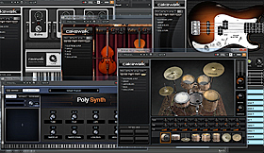
The US-1x2HR can improve your sound when playing music from your computer. No matter if you create your own dance music using software synths and other plug-ins or if you are the DJ on a birthday party – with its high audio quality and separate controls for headphones and line outputs (loudspeakers) the US-1x2HR easily turns your computer into a perfect-sounding playback device.
You may have noticed that your sound system is not very loud when powered directly from a computer. When using the US-1x2HR to feed your power amplifiers, its high line output level ensures you get the maximum power out of your sound system.
Highlights
- Maximum line output level of +6 dBV is enough for any power amp
- Standard 6.3-mm headphones output for monitoring
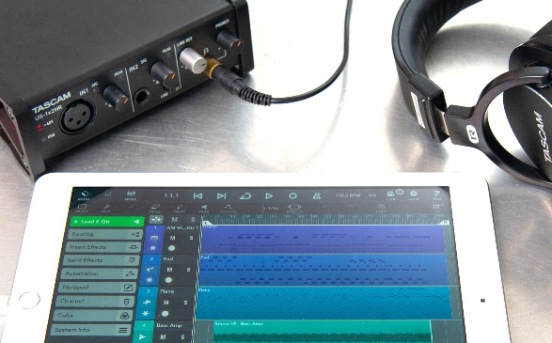

Instead of a computer, you can also use an iPad or iPhone together with the US-1x2HR to make music. Performance has been tested with not only the bundled digital audio workstation (Cubasis LE3), but also with other popular recording software – you can continue to use them even if you change DAW software.
- Connect with an iPad or iPhone
- Tested with many popular DAW applications

The Settings Panel, which is installed on your computer, comes with a variety of functions. You can choose whether direct monitoring is done in mono or stereo and adjust the balance between input and computer signals. You can also switch the hardware inputs on and off individually and set the Windows buffer size according to your working environment.
For online broadcasting, Internet communication and other live streaming applications, the US-HR series interfaces offer a Loopback function which can merge input signals 1/2 with signals 1/2 coming from the computer (each can be set to mono or stereo) and send that mix to the broadcasting or other software on the computer. A software slider allows to adjust the final “broadcast” volume independently from the unit’s line output level setting.
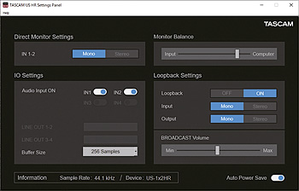
Inputs can be set on/off individually.
Buffer size can be set to a value between 4 and 2048 samples (Windows only)
Loopback can be set on/off, and each of the merged signal pairs can be switched mono/stereo
Slider for setting the Loopback master level (broadcast volume)

